RUDOLPH THE RED NOSED REINDEER
http://www.youtube.com/watch?v=cLf0DDt3Xiw

You know Dasher and Dancer and Prancer and Vixen,
Comet and Cupid and Donner and Blitzen.,
But do you recall?
The most famous reindeer of all?
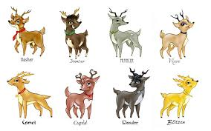
Rudolph the Red-Nosed Reindeer(reindeer)
Had a very shiny nose
And if you ever saw it
You would even say it glows
And all of the other reindeer(reindeer)
Used to laugh and call him names
They never let poor Rudolph(Rudolph)
Join in any reindeer games
Then one foggy Christmas Eve,
Santa came to say, ho ho ho
Rudolph with your nose so bright,
Won't you guide my sleigh tonight?(tonight)
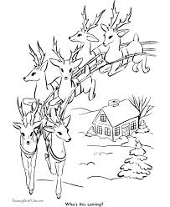
Then all the reindeer loved him(loved him)
As they shouted out with glee, yi~pe,
Rudolph the Red-Nosed Reindeer(reindeer)
You'll go down in history

