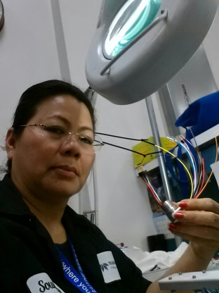 Julie Phouthavone is mentoring her nephew:

Julie Phouthavone is mentoring her nephew:

Julie: So, do you have any idea what you want to do when you finish school?
Andrew: Actually, I’d love to be an electrical assembler like you.
But I am not sure how to make that happen.
Julie: Are you sure it’s what you want to do?
Andrew: Definitely! But I know that not all electrical assemblers make a good living.
I’ll probably need to become an electrical engineer.
Julie: You’re right. I have taken many training programs and I am now going to college to advance in my job. But in my free time, I can fix all electrical problems at home and think of new gadgets.
Andrew: I want to study electrical engineering, too. It sounds really interesting.
Julie: Electrical engineering teachings you to design things, using science and math. This knowledge is extremely important for an electrical engineer.
Andrew: But I still have to finish high school. What can I do today?
Julie: When I was your age, I built and took apart a lot of radios and telephones.
Andrew: I love doing that! I’m taking apart my brother’s old CD player. I am learning a lot about how electronic devices work.
Julie: Why don’t you visit me at my work?
Andrew: Really? Thanks! That would be great.

