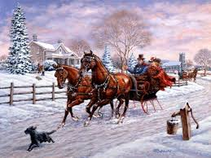
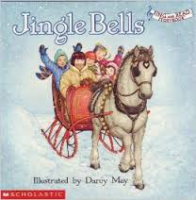
Jingle Bells
https://www.youtube.com/watch?v=v7s2VjwQSMw
Dashing through the snow
In a one-horse open sleigh
O'er the fields we go
Laughing all the way
Bells on bobtail ring'
Making spirits bright
What fun it is to ride and sing
A sleighing song tonight!
CHORUS:
Jingle bells, jingle bells,
Jingle all the way.
Oh! what fun it is to ride
In a one-horse open sleigh.
Jingle bells, jingle bells,
Jingle all the way;
Oh! what fun it is to ride
In a one-horse open sleigh.
A day or two ago
I thought I'd take a ride
And soon, Miss Fanny Bright
Was seated by my side,
The horse was lean and lank
Misfortune seemed his lot
He got into a drifted bank And then we got upsot .Chorus
Now the ground is white So go it while you’re young
Take the girls tonight and sing this sleighing song;
Just get a bobtailed bay Two forty for his speed
Then hitch him to an open sleigh And crack! You’ll take the lead
CHORUS:

