How to Buy a Blazer

By Nick Sullivan

First you need to tell the difference between a blazer, sport coat, and suit jacket.

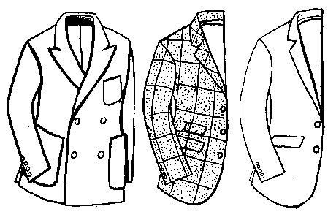

How would you explain the difference between a blazer, a sport coat, and a suit jacket?
— Mark Calicchio, San Pedro, Calif.

Fascinating question, Mark. In the U.S., blazer has come to mean anything that has sleeves and lapels and is worn with unmatched pants, but there are key differences between the three items you mention. In Europe and the tonier parts of the States — especially any place where messing about in boats is a big part of summer — a blazer [above, left] usually means a patch — pocket, navy — blue jacket with gold or (occasionally) silver buttons. The landlubberly sport coat [above, center], meanwhile, originally derived from the tweedy, robust coats worn while assisting in the untimely end of feathered or furry creatures. It had pockets with flaps, often an extra flapped ticket pocket, and was of softer construction than a suit jacket. As a modern fashion item, it should still retain the somewhat rustic, earthy look of its forebear (even when made in cashmere).
Finally, a suit jacket [above, right] will always be made of the finer stuff, i.e., worsted wool, and smooth to the touch. Still, all that said, it's rarely that cut — and — dried. Life's too short.

http://www.esquire.com/style/tips/blazer-vs-coat-vs-jacket-0709

